**Join us for our**

***Yom HaShoah***

***Holocaust Remembrance Program***

***Wednesday, April 19th***

***7:30pm*** **with** ***Guest Speaker Dr.*** ***Bernice Lerner***

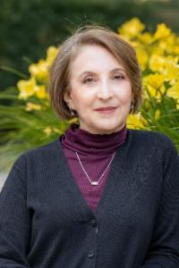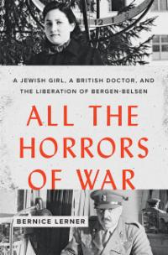

Dr. Lerner is the author of All the Horrors of War:

A Jewish Girl, a British Doctor and the Liberation of Bergen-Belson

and other writings on the Holocaust and virtue ethics.

As director of Boston University’s Center for Character and Social Responsibility, Bernice lectured widely, conducted professional development for educators, and taught courses on character education and on the Holocaust.

As dean of adult learning at Hebrew College, she created a host of adult learning programs, including the acclaimed *Me'ah,*a two-year journey

through Jewish history.

[Click here to register](https://templechaverim.shulcloud.com/form/Yom%20HaShoah.html) and receive the Zoom information

There will be copies of her book on-hand in our Temple library

as well as availability on [Amazon](https://www.amazon.com/All-Horrors-War-Liberation-Bergen-Belsen/dp/1421437708/ref=sr_1_1?crid=3TGE9ZYSISFLZ&keywords=all+the+horrors+of+war&qid=1677601892&sprefix=all+the+horrors%2Caps%2C114&sr=8-1) and anywhere books are sold. Should you wish to reserve her book prior to the event, please call our office (516-367-6100) to reserve a copy.

*****

Program offered by L'Dor Vador:

Holocaust Collective From Generation to Generation (Small Groups Initiative)